CSA 283: Final

Name: ______________________________________ Section: _____ _____

Please write legibly. Ask questions if something is unclear. Write down any assumptions you make.

Some useful formulas:
d_{trans} = L/R d_{prop} = d/s
utilization_{sender} = (L/R)/(L/R + RTT) exponential backoff = (K )512 bit times

L – packet length, R – link bandwidth, d – distance, s – propagation speed, RTT – round trip time

- Write the internet protocol stack layer to which each of the protocols below belongs.
(12 points)

DNS _______________

IP _______________

Ethernet _______________

UDP _______________

HTTP _______________

TCP _______________

- Contrast routes taken by packets in virtual circuit and datagram networks.
(4 points)

- A host is using 2-dimensional even parity to determine whether received data contains errors and whether they can be corrected. Consider the data and the parity bits below.

1 | 1 | 0 | 0 | 1 |  | 1
0 | 1 | 1 | 0 | 0 |  | 2
1 | 0 | 0 | 1 | 0 |  | 3
1 | 1 | 1 | 0 | 1 |  | 4
1 | 1 | 0 | 0
a | b | c | d

- Are there any errors (if so list coordinates)? How many errors are there?
(4 points)

- In a reliable connection oriented protocol such as TCP, what is the primary mechanism (sequence numbers, checksums, timers, ect.) that allows the protocol to deal with each of the following types of errors? (8 points)

Corrupted segment _______________

Duplicate segments _______________

Out of order segments _______________

Lost segment _______________

- Write the parity bit under odd parity for each of the bit sequences below.
(2 points)

010011010 ______________ 110011110 ______________

- State how many bytes compose the two different address types below. State what number base each type of address is normally expressed in. State the approximate size of the address space. (6 points)

 | Number of bytes | Number base | Approximate size  of address space
IPv4

Ethernet

- Use the constants below to answer the following questions. Show work for partial credit. Indicate the units for each answer. Show times to four decimal places. Assuming processing and queuing delays are negligible.

File Size 36 Mb
Packet Size 2.0 Mb
Link Bandwidth 20 Mbs
Link Lengths 40 Kilometers
Propagation Speed 2.8 x 10⁵ Kms

a. Calculate the propagation delay for a single link. (2 points)

b. Calculate the transmission delay for a single packet and a single router.
(2 points)

c. Assuming there are ten links connected by routers and that processing and queuing delays are negligible, calculate the time required for a single packet to reach its destination. (3 points)

d. Again assume there are ten links connected by routers and that processing and queuing delays are negligible. For pipelined transmission with a transmission window of infinite size, calculate the time needed for the entire file to reach the destination. (6 points)

- Consider the following scenario:

An application running on host1.mu.edu wants to find the IP address of jenny.uc.edu. Assume that all DNS caches are initially empty and that all DNS servers (including the local server) use caching. Except for the first query made by host1.mu.edu, assume all queries are handled iteratively. DNS server names are as follows:

TLD DNS server: dns.tld.edu
Local DNS server: dns.mu.edu
Authoritative DNS server: dns.uc.edu
Root DNS server: dns.root

- Draw arrows labeled with numbers to indicate the order of queries and responses sent before host1.mu.edu receives the IP address of jenny.uc.edu. The first arrow has already been drawn. (7 points)
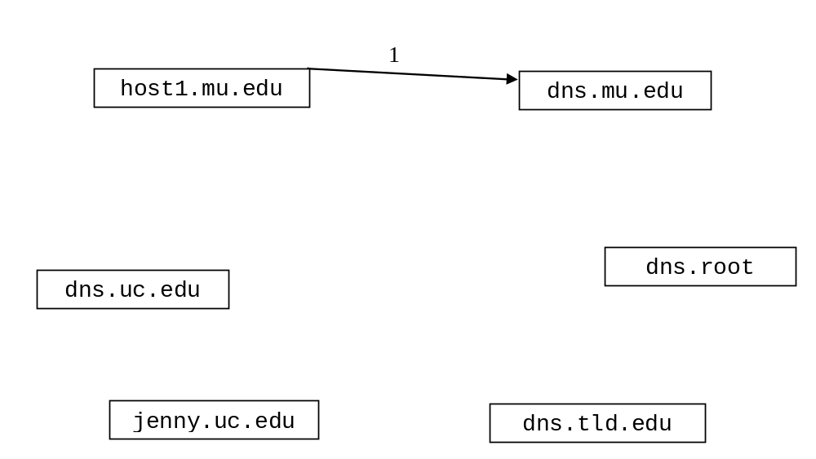
- Which server provides a resource record for containing the IP address of jenny.uc.edu? (2 points)

- In the above question, what type of resource record would be provided? (circle one) (2 points)

Type A Type NS Type CNAME Type MX

- Briefly describe why collision detection improves the efficiency of CSMA/CD protocols. (4 points)

- A group of received TCP segments has the following characteristics.

Sequence Number | Bytes of Data | Acknowledgment number  sent by receiver
500 | 70
620 | 80
700 | 70
830 | 40

Determine whether or not there are any gaps in the data received. If there are gaps, indicate by “byte numbers” the ranges of bytes that are missing.

Write the acknowledgment number that would be carried in the receivers reply to each segment. (8 points)

- Assume routers are identified by upper case letters (A, B, C, D, F) and subnets are identified by lower case letters (q, r, u, v, x, y, z).

The neighbors of a router are one hop away.

The following is the routing table at router D:

Destination Subnet | Next Router | Number of Hops to Dest.
w | A | 3
y | B | 5
z | B | 3
x | - | 1
r | A | 2
… | … | …

Assume that router D receives the following advertisement from neighbor A:

Destination Subnet | Next Router | Number of Hops to Dest.
z | C | 4
w | - | 1
x | - | 1
u | F | 6

As a result of the above advertisement, D may (or not) change its routing table. Show D’s updated routing table below: (10 points)

Destination Subnet | Next Router | Number of Hops to Dest.

- When using the TCP protocol, a server must establish a separate connection with each client. (2 points)

TRUE FALSE

- IP addresses are normally used by the transport layer for multiplexing and demultiplexing. (2 points)

TRUE FALSE

- The implementation of a UDP based server, would normally explicitly specify a port number when instantiating a DatagramSocket that clients will contact it on. (2 points)

TRUE FALSE

- Fast retransmit occurs in order to avoid an extended delay before resending a lost packet. (2 points)

TRUE FALSE

- Switches are physical layer devices that perform traffic isolation. (2 points)

TRUE FALSE

- “Plug-and-play” hubs use the DHCP protocol to obtain IP addresses.
(2 points)

TRUE FALSE

- 88-B2-2G-54-1A-FF is a valid MAC addresses. (2 points)

TRUE FALSE

- 192.321.0.2 is a valid IP addresses. (2 points)

TRUE FALSE

- Figure 2 (on the next page) is of a diagram of a simple network that includes six nodes (four hosts and two routers). A packet traveling from D to B must make three hops. Refer to figure 2 to answer the following questions.

  - What will the destination physical address be during the first hop? (2 points)

  - What will the destination IP address be during the second hop? (2 points)

  - What will the source IP address be during the third hop? (2 points)

  - What will the source physical address be during the third hop? (2 points)

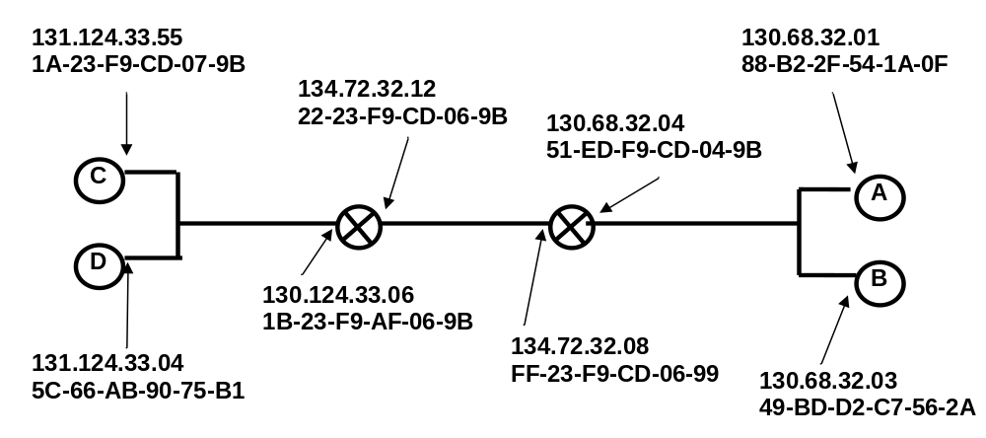
Figure 2: Simple Six Node Network

e. For the network in figure 2, suppose host A wants to send a packet to host B which has an IP address of 130.68.32.03. How would host A determine the physical address of host B? ( 2 points)

d. How many adapters does each router in figure 2 have? (2 points)

- Consider the LAN connecting hosts A through I together below.

hub
hub
hub
switch
A
B
C
D
F
G
H
I
1
2
3
E
Figure 1: LAN
The initial switch table is as follows:

address | Interface
A | 1
B | 1
E | 2
G | 3

a. Adapter I transmits a segment to adapter B: (4 points)

Which interfaces will the hub transmit the segment to?

How will the switch table be modified following the transmission?

b. Adapter B transmits a segment to adapter C: (4 points)

What interfaces will the hub transmit the segment to?

How will the switch table be modified following the transmission?
- TCP flow control uses the number of duplicate acks and timeouts to determine the transmission rate. Assume following events:

- transmission of data begins at time 0 (RTT 0) with a congestion window size of 1 MSS.
- timeout event occurs between at RTT 3 and RTT 4.
- three duplicates acks received between RTT 7 and RTT 8
- positive acks received during all other RTT intervals

Write the size of the congestion window and the threshold for each RTT period. The CongWin should be adjusted at the end of each RTT interval based on what happens in the interval.

Time | Size of congestion Window (CongWin) in Maximum Segment Sizes (MSS) | Threshold in MSS
0 RTT | 1 | n/a
1 RTT
2 RTT
3 RTT
4 RTT
5 RTT
6 RTT
7 RTT
8 RTT
9 RTT

(8 points)

- Implement a simple TCP server below. Do not worry about handling exceptions. Allow the main method to throw them to the OS. (12 points)

- The server should not be multi-threaded. Clients are handled sequentially.
- The Server listens on port number 7777.
- Clients send three floats using TCP.
- The Server calculates the product of the three numbers received and sends the product back to the client as a float.
- If the Server receives any negative number from any client, it will return the product and then exit.
- Close all open streams and sockets before the program exits.

import java.io.*;
import java.net.*;

public class ProductServer {

public static void main(String[] args) throws Exception
{

} // end main
} // end ProductServer class
- Implement a simple UDP client below. Do not worry about handling exceptions. Allow the main method to throw them to the OS. (12 points)

- The Client sends three floats in a single datagram using UDP to a server.
- The Server listens on port number 4455 at an IP address of 134.32.67.158.
- The product of the three floats is returned by the server as a float.
- The client prints out the product
- The client closes after receiving one product.
- Close all open streams and sockets before the program exits.

import java.io.*;
import java.net.*;

public class ProductClient {

public static void main(String[] args) throws Exception
{

} // end main
} // end ProductClient class

